A

PROJECT REPORT

ON

“ONLINE VOTING SYSTEM”

Guided By: Submitted By:-
Mr. Anshuman Soni Priya Ganguli
Third Year(C.S.E -C.C)

DEPARTMENT OF COMPUTER ENGINEERING
GRAPHIC ERA DEEMED TO BE UNIVERSITY
DEHRADUN
(2017-2018)

Abstract : The project "Voting Software" aims at making the voting process easy in cooperative societies. Presently voting is performed using ballot paper and the counting is done manually, hence it consumes a lot of time. There can be possibility of invalid votes. All these makes election a tedious task. In our proposed system voting and counting is done with the help of computer. It saves time, avoid error in counting and there will be no invalid votes. It makes the election process easy
Functional Requirements : •To count the total number of votes. •To calculate the percentage of total votes. •To calculate votes for each candidate. •To calculate percentage of votes for each candidate. •To check for duplication. •To Find the winning persons in each section. •All the process above mentioned should be done fast
Details : Modules We have devised the following modules according to the requirements of the organization. •Administrator Module •User Module Administrator has the whole authority of the organization .He is the one who maintains all the aspects of voters and candidates. His functionalities include insertion, updation ,deletion of both the voter and the candidate. He is responsible for allowing persons to vote. User's have the provision to view the list of voters candidates and results and to vote for their desired candidate.
2. SYSTEM STUDY
2.1 FEASIBILITY STUDY
The feasibility of the project is analyzed in this phase and business proposal is put forth with a very general plan for the project and some cost estimates. During system analysis the feasibility study of the proposed system is to be carried out. This is to ensure that the proposed system is not a burden to the company. For feasibility analysis, some understanding of the major requirements for the system is essential.
Three key considerations involved in the feasibility analysis are
- ECONOMICAL FEASIBILITY
- TECHNICAL FEASIBILITY
- SOCIAL FEASIBILITY
ECONOMICAL FEASIBILITY
This study is carried out to check the economic impact that the system will have on the organization. The amount of fund that the company can pour into the research and development of the system is limited. The expenditures must be justified. Thus the developed system as well within the budget and this was achieved because most of the technologies used are freely available. Only the customized products had to be purchased.

TECHNICAL FEASIBILITY
This study is carried out to check the technical feasibility, that is, the technical requirements of the system. Any system developed must not have a high demand on the available technical resources. This will lead to high demands on the available technical resources. This will lead to high demands being placed on the client. The developed system must have a modest requirement, as only minimal or null changes are required for implementing this system.
SOCIAL FEASIBILITY
The aspect of study is to check the level of acceptance of the system by the user. This includes the process of training the user to use the system efficiently. The user must not feel threatened by the system, instead must accept it as a necessity. The level of acceptance by the users solely depends on the methods that are employed to educate the user about the system and to make him familiar with it. His level of confidence must be raised so that he is also able to make some constructive criticism, which is welcomed, as he is the final user of the system.
System Specification

System Requirements:
Software Requirements:

- Operating system : - Windows XP.
- Coding Language : ASP.Net with C#
- Data Base : SQL Server 2005

SYSTEM DESIGN
Data Flow Diagram / Use Case Diagram / Flow Diagram
The DFD is also called as bubble chart. It is a simple graphical formalism that can be used to represent a system in terms of the input data to the system, various processing carried out on these data, and the output data is generated by the system.

DFD(Data Flow Diagram)

0-Level(Context Level) DFD

1.0
Process
User
System

1-Level DFD
1.0.0
Polling Process
Person
Login

UserLogin

2-Level DFD

Total No. of Votes

Registration
User Login

User Details
User Details
Candidate name
User Details
1.0.0
Login Process
Admin
Home
TotalCandidateofVote
Result of Candidate votes

User Details
Admin
Percent Candidate Votes

Admin database
_______________

Sequential diagram

Total Number Votes

Percentage of All Votes
Result of Cadidate Vote

Registration
View no. of
votes
View Candidate votes
Admin
Percentage candidate Vote
View Candidate votes
In Percentage
Give all details of
Candidate

ADMINSTRATOR

Use case diagrams

Candidate



System
Candidate

ADMINSTRATOR



System
ADMINSTRATOR

Software Environment
4.1 Features OF. Net
Microsoft .NET is a set of Microsoft software technologies for rapidly building and integrating XML Web services, Microsoft Windows-based applications, and Web solutions. The .NET Framework is a language-neutral platform for writing programs that can easily and securely interoperate. There’s no language barrier with .NET: there are numerous languages available to the developer including Managed C++, C#, Visual Basic and Java Script. The .NET framework provides the foundation for components to interact seamlessly, whether locally or remotely on different platforms. It standardizes common data types and communications protocols so that components created in different languages can easily interoperate.

“.NET” is also the collective name given to various software components built upon the .NET platform. These will be both products (Visual Studio.NET and Windows.NET Server, for instance) and services (like Passport, .NET My Services, and so on).
THE .NET FRAMEWORK
The .NET Framework has two main parts:
1. The Common Language Runtime (CLR).
2. A hierarchical set of class libraries.
The CLR is described as the “execution engine” of .NET. It provides the environment within which programs run. The most important features are
- Conversion from a low-level assembler-style language, called Intermediate Language (IL), into code native to the platform being executed on.
- Memory management, notably including garbage collection.
- Checking and enforcing security restrictions on the running code.
- Loading and executing programs, with version control and other such features.
- The following features of the .NET framework are also worth description:
Managed Code
The code that targets .NET, and which contains certain extra Information - “metadata” - to describe itself. Whilst both managed and unmanaged code can run in the runtime, only managed code contains the information that allows the CLR to guarantee, for instance, safe execution and interoperability.
Managed Data
With Managed Code comes Managed Data. CLR provides memory allocation and Deal location facilities, and garbage collection. Some .NET languages use Managed Data by default, such as C#, Visual Basic.NET and JScript.NET, whereas others, namely C++, do not. Targeting CLR can, depending on the language you’re using, impose certain constraints on the features available. As with managed and unmanaged code, one can have both managed and unmanaged data in .NET applications - data that doesn’t get garbage collected but instead is looked after by unmanaged code.
Common Type System
The CLR uses something called the Common Type System (CTS) to strictly enforce type-safety. This ensures that all classes are compatible with each other, by describing types in a common way. CTS define how types work within the runtime, which enables types in one language to interoperate with types in another language, including cross-language exception handling. As well as ensuring that types are only used in appropriate ways, the runtime also ensures that code doesn’t attempt to access memory that hasn’t been allocated to it.
Common Language Specification
The CLR provides built-in support for language interoperability. To ensure that you can develop managed code that can be fully used by developers using any programming language, a set of language features and rules for using them called the Common Language Specification (CLS) has been defined. Components that follow these rules and expose only CLS features are considered CLS-compliant.
THE CLASS LIBRARY
.NET provides a single-rooted hierarchy of classes, containing over 7000 types. The root of the namespace is called System; this contains basic types like Byte, Double, Boolean, and String, as well as Object. All objects derive from System. Object. As well as objects, there are value types. Value types can be allocated on the stack, which can provide useful flexibility. There are also efficient means of converting value types to object types if and when necessary.
The set of classes is pretty comprehensive, providing collections, file, screen, and network I/O, threading, and so on, as well as XML and database connectivity.
The class library is subdivided into a number of sets (or namespaces), each providing distinct areas of functionality, with dependencies between the namespaces kept to a minimum.
LANGUAGES SUPPORTED BY .NET
The multi-language capability of the .NET Framework and Visual Studio .NET enables developers to use their existing programming skills to build all types of applications and XML Web services. The .NET framework supports new versions of Microsoft’s old favorites Visual Basic and C++ (as VB.NET and Managed C++), but there are also a number of new additions to the family.
Visual Basic .NET has been updated to include many new and improved language features that make it a powerful object-oriented programming language. These features include inheritance, interfaces, and overloading, among others. Visual Basic also now supports structured exception handling, custom attributes and also supports multi-threading.
Visual Basic .NET is also CLS compliant, which means that any CLS-compliant language can use the classes, objects, and components you create in Visual Basic .NET.
Managed Extensions for C++ and attributed programming are just some of the enhancements made to the C++ language. Managed Extensions simplify the task of migrating existing C++ applications to the new .NET Framework.
C# is Microsoft’s new language. It’s a C-style language that is essentially “C++ for Rapid Application Development”. Unlike other languages, its specification is just the grammar of the language. It has no standard library of its own, and instead has been designed with the intention of using the .NET libraries as its own.
Microsoft Visual J# .NET provides the easiest transition for Java-language developers into the world of XML Web Services and dramatically improves the interoperability of Java-language programs with existing software written in a variety of other programming languages.
Active State has created Visual Perl and Visual Python, which enable .NET-aware applications to be built in either Perl or Python. Both products can be integrated into the Visual Studio .NET environment. Visual Perl includes support for Active State’s Perl Dev Kit.
Other languages for which .NET compilers are available include
- FORTRAN
- COBOL
- Eiffel

Fig1 .Net Framework
ASP.NET  XML WEB SERVICES | Windows Forms
Base Class Libraries
Common Language Runtime
Operating System

C#.NET is also compliant with CLS (Common Language Specification) and supports structured exception handling. CLS is set of rules and constructs that are supported by the CLR (Common Language Runtime). CLR is the runtime environment provided by the .NET Framework; it manages the execution of the code and also makes the development process easier by providing services.
C#.NET is a CLS-compliant language. Any objects, classes, or components that created in C#.NET can be used in any other CLS-compliant language. In addition, we can use objects, classes, and components created in other CLS-compliant languages in C#.NET .The use of CLS ensures complete interoperability among applications, regardless of the languages used to create the application.

CONSTRUCTORS AND DESTRUCTORS:
Constructors are used to initialize objects, whereas destructors are used to destroy them. In other words, destructors are used to release the resources allocated to the object. In C#.NET the sub finalize procedure is available. The sub finalize procedure is used to complete the tasks that must be performed when an object is destroyed. The sub finalize procedure is called automatically when an object is destroyed. In addition, the sub finalize procedure can be called only from the class it belongs to or from derived classes.
GARBAGE COLLECTION
Garbage Collection is another new feature in C#.NET. The .NET Framework monitors allocated resources, such as objects and variables. In addition, the .NET Framework automatically releases memory for reuse by destroying objects that are no longer in use.
In C#.NET, the garbage collector checks for the objects that are not currently in use by applications. When the garbage collector comes across an object that is marked for garbage collection, it releases the memory occupied by the object.
OVERLOADING
Overloading is another feature in C#. Overloading enables us to define multiple procedures with the same name, where each procedure has a different set of arguments. Besides using overloading for procedures, we can use it for constructors and properties in a class.

MULTITHREADING:
C#.NET also supports multithreading. An application that supports multithreading can handle multiple tasks simultaneously, we can use multithreading to decrease the time taken by an application to respond to user interaction.
STRUCTURED EXCEPTION HANDLING
C#.NET supports structured handling, which enables us to detect and remove errors at runtime. In C#.NET, we need to use Try…Catch…Finally statements to create exception handlers. Using Try…Catch…Finally statements, we can create robust and effective exception handlers to improve the performance of our application.
THE .NET FRAMEWORK
The .NET Framework is a new computing platform that simplifies application development in the highly distributed environment of the Internet.
OBJECTIVES OF. NET FRAMEWORK
1. To provide a consistent object-oriented programming environment whether object codes is stored and executed locally on Internet-distributed, or executed remotely.
2. To provide a code-execution environment to minimizes software deployment and guarantees safe execution of code.
3. Eliminates the performance problems.
There are different types of application, such as Windows-based applications and Web-based applications.
Front end used :
Microsoft Visual Studio. Net used as front end tool. The reason for selecting Visual Studio dot Net as front end tool as follows:
- Visual Studio .Net has flexibility , allowing one or more language to interoperate to provide the solution. This Cross Language Compatibility allows to do project at faster rate.
- Visual Studio. Net has Common Language Runtime , that allows all the component to converge into one intermediate format and then can interact.
- Visual Studio. Net has provide excellent security when your application is executed in the system
- Visual Studio.Net has flexibility, allowing us to configure the working environment to best suit our individual style. We can choose between a single and multiple document interfaces, and we can adjust the size and positioning of the various IDE elements.
- Visual Studio. Net has Intelligence feature that make the coding easy and also Dynamic help provides very less coding time.
- The working environment in Visual Studio.Net is often referred to as Integrated Development Environment because it integrates many different functions such as design, editing, compiling and debugging within a common environment. In most traditional development tools, each of separate program, each with its own interface.
- The Visual Studio.Net language is quite powerful – if we can imagine a programming task and accomplished using Visual Basic .Net.
- After creating a Visual Studio. Net application, if we want to distribute it to others we can freely distribute any application to anyone who uses Microsoft windows. We can distribute our applications on disk, on CDs, across networks, or over an intranet or the internet.
- Toolbars provide quick access to commonly used commands in the programming environment. We click a button on the toolbar once to carry out the action represented by that button. By default, the standard toolbar is displayed when we start Visual Basic. Additional toolbars for editing, form design, and debugging can be toggled on or off from the toolbars command on the view menu.
- Many parts of Visual Studio are context sensitive. Context sensitive means we can get help on these parts directly without having to go through the help menu. For example, to get help on any keyword in the Visual Basic language, place the insertion point on that keyword in the code window and press F1.
- Visual Studio interprets our code as we enter it, catching and highlighting most syntax or spelling errors on the fly. It’s almost like having an expert watching over our shoulder as we enter our code.

FEATURES OF VISUAL STUDIO .NET

What is .NET?

When .NET was announced in late 1999, Microsoft positioned the technology as a platform for building and consuming Extensible Markup Language (XML) Web services. XML Web services allow any type of application, be it a Windows- or browser-based application running on any type of computer system, to consume data from any type of server over the Internet. The reason this idea is so great is the way in which the XML messages are transferred: over established standard protocols that exist today. Using protocols such as SOAP, HTTP, and SMTP, XML Web services make it possible to expose data over the wire with little or no modifications to your existing code.
Since the initial announcement of the .NET Framework, it's taken on many new and different meanings to different people. To a developer, .NET means a great environment for creating robust distributed applications. To an IT manager, .NET means simpler deployment of applications to end users, tighter security, and simpler management. To a CTO or CIO, .NET means happier developers using state-of-the-art development technologies and a smaller bottom line. To understand why all these statements are true, you need to get a grip on what the .NET Framework consists of, and how it's truly a revolutionary step forward for application architecture, development, and deployment.

.NET Framework
Now that you are familiar with the major goals of the .NET Framework, let's briefly examine its architecture. The .NET Framework sits on top of the operating system, which can be a few different flavors of Windows and consists of a number of components .NET is essentially a system application that runs on Windows.

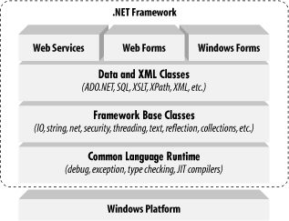
Conceptually, the CLR and the JVM are similar in that they are both runtime infrastructures that abstract the underlying platform differences. However, while the JVM officially supports only the Java language, the CLR supports any language that can be represented in its Common Intermediate Language (CIL). The JVM executes bytecode, so it can, in principle, support many languages, too. Unlike Java's bytecode, though, CIL is never interpreted. Another conceptual difference between the two infrastructures is that Java code runs on any platform with a JVM, whereas .NET code runs only on platforms that support the CLR. In April 2003, the International Organization for Standardization and the International Electrotechnical Committee (ISO/IEC) recognized a functional subset of the CLR, known as the Common Language Interface (CLI), as an international standard.
This development, initiated by Microsoft and developed by ECMA International, a European standards organization, opens the way for third parties to implement their own versions of the CLR on other platforms, such as Linux or Mac OS X. For information on third-party and open source projects working to implement the ISO/IEC CLI and C# specifications.
The layer on top of the CLR is a set of framework base classes. This set of classes is similar to the set of classes found in STL, MFC, ATL, or Java. These classes support rudimentary input and output functionality, string manipulation, security management, network communications, thread management, text management, reflection functionality, collections functionality, as well as other functions.
On top of the framework base classes is a set of classes that extend the base classes to support data management and XML manipulation. These classes, called ADO.NET, support persistent data management—data that is stored on backend databases. Alongside the data classes, the .NET Framework supports a number of classes to let you manipulate XML data and perform XML searching and XML translations.
Classes in three different technologies (including web services, Web Forms, and Windows Forms) extend the framework base classes and the data and XML classes. Web services include a number of classes that support the development of lightweight distributed components, which work even in the face of firewalls and NAT software. These components support plug-and-play across the Internet, because web services employ standard HTTP and SOAP.
Web Forms, the key technology behind ASP.NET, include a number of classes that allow you to rapidly develop web Graphical User Interface (GUI) applications. If you're currently developing web applications with Visual Interdev, you can think of Web Forms as a facility that allows you to develop web GUIs using the same drag-and-drop approach as if you were developing the GUIs in Visual Basic. Simply drag-and-drop controls onto your Web Form, double-click on a control, and write the code to respond to the associated event.
Windows Forms support a set of classes that allow you to develop native Windows GUI applications. You can think of these classes collectively as a much better version of the MFC in C++ because they support easier and more powerful GUI development and provide a common, consistent interface that can be used in all languages.

The Common Language Runtime
At the heart of the .NET Framework is the common language runtime. The common language runtime is responsible for providing the execution environment that code written in a .NET language runs under. The common language runtime can be compared to the Visual Basic 6 runtime, except that the common language runtime is designed to handle all .NET languages, not just one, as the Visual Basic 6 runtime did for Visual Basic 6. The following list describes some of the benefits the common language runtime gives you:
- Automatic memory management
- Cross-language debugging
- Cross-language exception handling
- Full support for component versioning
- Access to legacy COM components
- XCOPY deployment
- Robust security model
You might expect all those features, but this has never been possible using Microsoft development tools. The common language runtime fits into the .NET Framework.

The common language runtime and the .NET Framework.
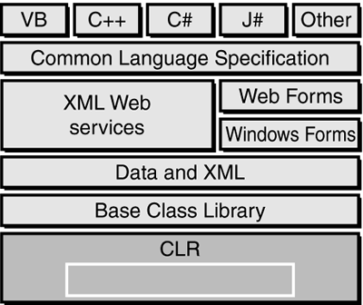

Note:
Code written using a .NET language is known as managed code. Code that uses anything but the common language runtime is known as unmanaged code. The common language runtime provides a managed execution environment for .NET code, whereas the individual runtimes of non-.NET languages provide an unmanaged execution environment.
Inside the Common Language Runtime
The common language runtime enables code running in its execution environment to have features such as security, versioning, memory management and exception handling because of the way .NET code actually executes.
When you compiled Visual Basic 6 forms applications, you had the ability to compile down to native node or p-code. Visual Basic 6 compiler options dialog should refresh your memory of what the Visual Basic 6 options dialog looked like.

When you compile your applications in .NET, you aren't creating anything in native code. When you compile in .NET, you're converting your code—no matter what .NET language you're using—into an assembly made up of an intermediate language called Microsoft Intermediate Language (MSIL or just IL, for short). The IL contains all the information about your application, including methods, properties, events, types, exceptions, security objects, and so on, and it also includes metadata about what types in your code can or cannot be exposed to other applications. This was called a type library in Visual Basic 6 or an IDL (interface definition language) file in C++. In .NET, it's simply the metadata that the IL contains about your assembly.
Note
The file format for the IL is known as PE (portable executable) format, which is a standard format for processor-specific execution.
When a user or another component executes your code, a process occurs called just-in-time (JIT) compilation, and it's at this point that the IL is converted into the specific machine language of the processor it's executing on. This makes it very easy to port a .NET application to any type of operating system on any type of processor because the IL is simply waiting to be consumed by a JIT compiler.
Note
The first time an assembly is called in .NET, the JIT process occurs. Subsequent calls don't re-JIT the IL; the previously JITted IL remains in cache and is used over and over again. When you learn about Application Center Test, you also see how the warm-up time of the JIT process can affect application performance.
Understanding the process of compilation in .NET is very important because it makes clear how features such as cross-language debugging and exception handling are possible. You're not actually compiling to any machine-specific code—you're simply compiling down to an intermediate language that's the same for all .NET languages. The IL produced by J# .NET and C# looks just like the IL created by the Visual Basic .NET compiler. These instructions are the same, only how you type them in Visual Studio .NET is different, and the power of the common language runtime is apparent.
When the IL code is JITted into machine-specific language, it does so on an as-needed basis. If your assembly is 10MB and the user is only using a fraction of that 10MB, only the required IL and its dependencies are compiled to machine language. This makes for a very efficient execution process. But during this execution, how does the common language runtime make sure that the IL is correct? Because the compiler for each language creates its own IL, there must be a process that makes sure what's compiling won't corrupt the system. The process that validates the IL is known as verification. Figure 1.5 demonstrates the process the IL goes through before the code actually executes.
Figure 1.5. The JIT process and verification.

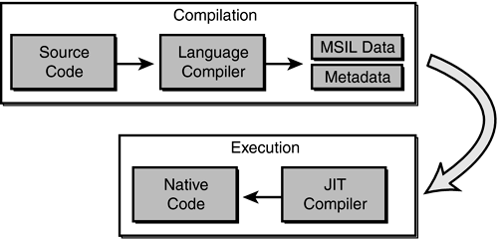
When code is JIT compiled, the common language runtime checks to make sure that the IL is correct. The rules that the common language runtime uses for verification are set forth in the Common Language Specification (CLS) and the Common Type System (CTS).

The .NET Framework Class Library
The second most important piece of the .NET Framework is the .NET Framework class library (FCL). As you've seen, the common language runtime handles the dirty work of actually running the code you write. But to write the code, you need a foundation of available classes to access the resources of the operating system, database server, or file server. The FCL is made up of a hierarchy of namespaces that expose classes, structures, interfaces, enumerations, and delegates that give you access to these resources.
The namespaces are logically defined by functionality. For example, the System.Data namespace contains all the functionality available to accessing databases. This namespace is further broken down into System.Data.SqlClient, which exposes functionality specific to SQL Server, and System.Data.OleDb, which exposes specific functionality for accessing OLEDB data sources.
Specific assemblies within the FCL don’t necessarily define the bounds of a namespace; rather, they're focused on functionality and logical grouping. In total, there are more than 20,000 classes in the FCL, all logically grouped in a hierarchical manner. Figure 1.8 shows where the FCL fits into the .NET Framework and the logical grouping of namespaces.

Figure 1.8. The .NET Framework class library.

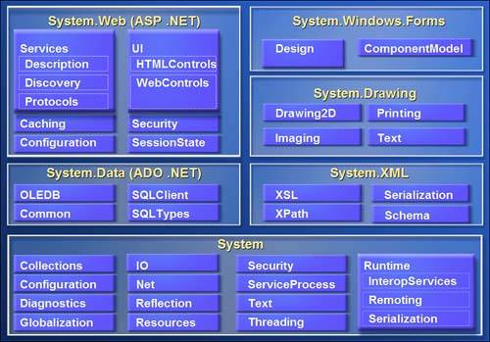

To use an FCL class in your application, you use the Imports statement in Visual Basic .NET or the using statement in C#. When you reference a namespace in Visual Basic .NET or C#, you also get the convenience of auto-complete and auto-list members when you access the objects' types using Visual Studio .NET. This makes it very easy to determine what types are available for each class in the namespace you're using. As you'll see over the next several weeks, it's very easy to start coding in Visual Studio .NET.
The Structure of a .NET Application
To understand how the common language runtime manages code execution, you must examine the structure of a .NET application. The primary unit of a .NET application is the assembly. An assembly is a self-describing collection of code, resources, and metadata. The assembly manifest contains information about what is contained within the assembly. The assembly manifest provides:
- Identity information, such as the assembly’s name and version number
- A list of all types exposed by the assembly
- A list of other assemblies required by the assembly
- A list of code access security instructions, including permissions required by the assembly and permissions to be denied the assembly
Each assembly has one and only one assembly manifest, and it contains all the description information for the assembly. However, the assembly manifest can be contained in its own file or within one of the assembly’s modules.
An assembly contains one or more modules. A module contains the code that makes up your application or library, and it contains metadata that describes that code. When you compile a project into an assembly, your code is converted from high-level code to IL.
Because all managed code is first converted to IL code, applications written in different languages can easily interact. For example, one developer might write an application in Visual C# that accesses a DLL in Visual Basic .NET. Both resources will be converted to IL modules before being executed, thus avoiding any language-incompatibility issues.
Each module also contains a number of types. Types are templates that describe a set of data encapsulation and functionality. There are two kinds of types: reference types (classes) and value types (structures). These types are discussed in greater detail in Lesson 2 of this chapter. Each type is described to the common language runtime in the assembly manifest. A type can contain fields, properties, and methods, each of which should be related to a common functionality. For example, you might have a class that represents a bank account. It contains fields, properties, and methods related to the functions needed to implement a bank account.
A field represents storage of a particular type of data. One field might store the name of an account holder, for example. Properties are similar to fields, but properties usually provide some kind of validation when data is set or retrieved. You might have a property that represents an account balance. When an attempt is made to change the value, the property can check to see if the attempted change is greater than a predetermined limit. If the value is greater than the limit, the property does not allow the change.
Methods represent behavior, such as actions taken on data stored within the class or changes to the user interface. Continuing with the bank account example, you might have a Transfer method that transfers a balance from a checking account to a savings account, or an Alert method that warns users when their balances fall below a predetermined level.
Compilation and Execution of a .NET Application
When you compile a .NET application, it is not compiled to binary machine code; rather, it is converted to IL. This is the form that your deployed application takes—one or more assemblies consisting of executable files and DLL files in IL form. At least one of these assemblies will contain an executable file that has been designated as the entry point for the application.
When execution of your program begins, the first assembly is loaded into memory. At this point, the common language runtime examines the assembly manifest and determines the requirements to run the program. It examines security permissions requested by the assembly and compares them with the system’s security policy. If the system’s security policy does not allow the requested permissions, the application will not run.
If the application passes the system’s security policy, the common language runtime executes the code. It creates a process for the application to run in and begins application execution. When execution starts, the first bit of code that needs to be executed is loaded into memory and compiled into native binary code from IL by the common language runtime’s Just-In-Time (JIT) compiler.
Once compiled, the code is executed and stored in memory as native code. Thus, each portion of code is compiled only once when an application executes. Whenever program execution branches to code that has not yet run, the JIT compiler compiles it ahead of execution and stores it in memory as binary code. This way, application performance is maximized because only the parts of a program that are executed are compiled.
The .NET Framework base class library contains the base classes that provide many of the services and objects you need when writing your applications. The class library is organized into namespaces. A namespace is a logical grouping of types that perform related functions. For example, the System.Windows.Forms namespace contains all the types that make up Windows forms and the controls used in those forms.
Namespaces are logical groupings of related classes. The namespaces in the .NET base class library are organized hierarchically. The root of the .NET Framework is the System namespace. Other namespaces can be accessed with the period operator. A typical namespace construction appears as follows:
System
System.Data
System.Data.SQLClient
The first example refers to the System namespace. The second refers to the System.Data namespace. The third example refers to the System.Data.SQLClient namespace. Table 1.1 introduces some of the more commonly used .NET base class namespaces.
Table 1-1. Representative .NET Namespaces
Namespace | Description
System | This namespace is the root for many of the low-level types required by the .NET Framework. It is the root for primitive data types as well, and it is the root for all the other namespaces in the .NET base class library.
System.ComponentModel | This namespace contains classes involved in component creation and containment, such as attributes, type converters, and license providers.
System. Data | This namespace contains classes required for database access and manipulations, as well as additional namespaces used for data access.
System.Data.Common | This namespace contains a set of classes that are shared by the .NET managed data providers.
System.Data.OleDb | This namespace contains classes that make up the managed data provider for OLE DB data access.
System.Data.SQLClient | This namespace contains classes that are optimized for interacting with Microsoft SQL Server.
System. Drawing | This namespace exposes GDI+ functionality and provides classes that facilitate graphics rendering.
System.IO | In this namespace, you will find types for handling file system I/O.
System. Math | This namespace is home to common mathematics functions such as extracting roots and trigonometry.
System. Reflection | This namespace provides support for obtaining information and dynamic creation of types at runtime.
System. Security | This namespace is home to types dealing with permissions, cryptography, and code access security.
System. Threading | This namespace contains classes that facilitate the implementation of multithreaded applications.
System.Windows.Forms | This namespace contains types involved in creating standard Windows applications. Classes that represent forms and controls reside here as well.
4.3 Features of SQL-SERVER

The OLAP Services feature available in SQL Server version 7.0 is now called SQL Server 2000 Analysis Services. The term OLAP Services has been replaced with the term Analysis Services. Analysis Services also includes a new data mining component. The Repository component available in SQL Server version 7.0 is now called Microsoft SQL Server 2000 Meta Data Services. References to the component now use the term Meta Data Services. The term repository is used only in reference to the repository engine within Meta Data Services
SQL-SERVER database consist of six type of objects,
They are,
1. TABLE
2. QUERY
3. FORM
4. REPORT
5. MACRO
TABLE:
A database is a collection of data about a specific topic.
VIEWS OF TABLE:
We can work with a table in two types,
1. Design View
2. Datasheet View
Design View
To build or modify the structure of a table we work in the table design view. We can specify what kind of data will be hold.
Datasheet View
To add, edit or analyses the data itself we work in tables datasheet view mode.
QUERY:
A query is a question that has to be asked the data. Access gathers data that answers the question from one or more table. The data that make up the answer is either dynaset (if you edit it) or a snapshot (it cannot be edited).Each time we run query, we get latest information in the dynaset. Access either displays the dynaset or snapshot for us to view or perform an action on it, such as deleting or updating.
Coding

6. SYSTEM TESTING
The purpose of testing is to discover errors. Testing is the process of trying to discover every conceivable fault or weakness in a work product. It provides a way to check the functionality of components, sub assemblies, assemblies and/or a finished product It is the process of exercising software with the intent of ensuring that the
Software system meets its requirements and user expectations and does not fail in an unacceptable manner. There are various types of test. Each test type addresses a specific testing requirement.

TYPES OF TESTS

Unit testing
Unit testing involves the design of test cases that validate that the internal program logic is functioning properly, and that program inputs produce valid outputs. All decision branches and internal code flow should be validated. It is the testing of individual software units of the application .it is done after the completion of an individual unit before integration. This is a structural testing, that relies on knowledge of its construction and is invasive. Unit tests perform basic tests at component level and test a specific business process, application, and/or system configuration. Unit tests ensure that each unique path of a business process performs accurately to the documented specifications and contains clearly defined inputs and expected results.
Integration testing
Integration tests are designed to test integrated software components to determine if they actually run as one program. Testing is event driven and is more concerned with the basic outcome of screens or fields. Integration tests demonstrate that although the components were individually satisfaction, as shown by successfully unit testing, the combination of components is correct and consistent. Integration testing is specifically aimed at exposing the problems that arise from the combination of components.

Functional test
Functional tests provide systematic demonstrations that functions tested are available as specified by the business and technical requirements, system documentation, and user manuals.
Functional testing is centered on the following items:
Valid Input : identified classes of valid input must be accepted.
Invalid Input : identified classes of invalid input must be rejected.
Functions : identified functions must be exercised.
Output : identified classes of application outputs must be exercised.
Systems/Procedures: interfacing systems or procedures must be invoked.
Organization and preparation of functional tests is focused on requirements, key functions, or special test cases. In addition, systematic coverage pertaining to identify Business process flows; data fields, predefined processes, and successive processes must be considered for testing. Before functional testing is complete, additional tests are identified and the effective value of current tests is determined.
System Test
System testing ensures that the entire integrated software system meets requirements. It tests a configuration to ensure known and predictable results. An example of system testing is the configuration oriented system integration test. System testing is based on process descriptions and flows, emphasizing pre-driven process links and integration points.

White Box Testing
White Box Testing is a testing in which in which the software tester has knowledge of the inner workings, structure and language of the software, or at least its purpose. It is purpose. It is used to test areas that cannot be reached from a black box level.

Black Box Testing
Black Box Testing is testing the software without any knowledge of the inner workings, structure or language of the module being tested. Black box tests, as most other kinds of tests, must be written from a definitive source document, such as specification or requirements document, such as specification or requirements document. It is a testing in which the software under test is treated, as a black box .you cannot “see” into it. The test provides inputs and responds to outputs without considering how the software works.
6.1 Unit Testing:Unit testing is usually conducted as part of a combined code and unit test phase of the software lifecycle, although it is not uncommon for coding and unit testing to be conducted as two distinct phases.

Test strategy and approach
Field testing will be performed manually and functional tests will be written in detail.
Test objectives
- All field entries must work properly.
- Pages must be activated from the identified link.
- The entry screen, messages and responses must not be delayed.
Features to be tested
- Verify that the entries are of the correct format
- No duplicate entries should be allowed
- All links should take the user to the correct page.

6.2 Integration Testing
Software integration testing is the incremental integration testing of two or more integrated software components on a single platform to produce failures caused by interface defects.
The task of the integration test is to check that components or software applications, e.g. components in a software system or – one step up – software applications at the company level – interact without error.
Test Results: All the test cases mentioned above passed successfully. No defects encountered.

6.3 Acceptance Testing:

User Acceptance Testing is a critical phase of any project and requires significant participation by the end user. It also ensures that the system meets the functional requirements.

Test Results: All the test cases mentioned above passed successfully. No defects encountered.

Coding involved in this project:
1.Voter’s Registration:
protected void Button1_Click(object sender, EventArgs e)
{
if (CompareValidator1.IsValid==true&& RequiredFieldValidator1.IsValid == true && RequiredFieldValidator2.IsValid == true && RequiredFieldValidator3.IsValid == true && RequiredFieldValidator4.IsValid == true)

{
String votername = TextBox1.Text;
String dob = TextBox2.Text;
String city = TextBox3.Text;
String password = TextBox4.Text;
String username = TextBox6.Text;
SqlConnection con = new SqlConnection(@"Data Source = (LocalDB)\MSSQLLocalDB; AttachDbFilename = C:\Users\hp\source\repos\WebSite3\WebSite3\App_Data\Database.mdf; Integrated Security = True");
con.Open();
SqlCommand com = new SqlCommand("insert into Register values('" + votername + "'," + dob + ",'" + city + "','"+password+"','" + username + "')", con);
SqlDataReader dr = com.ExecuteReader();
Response.Redirect("Login.aspx");
}
Screenshot of Voter’s Registration:
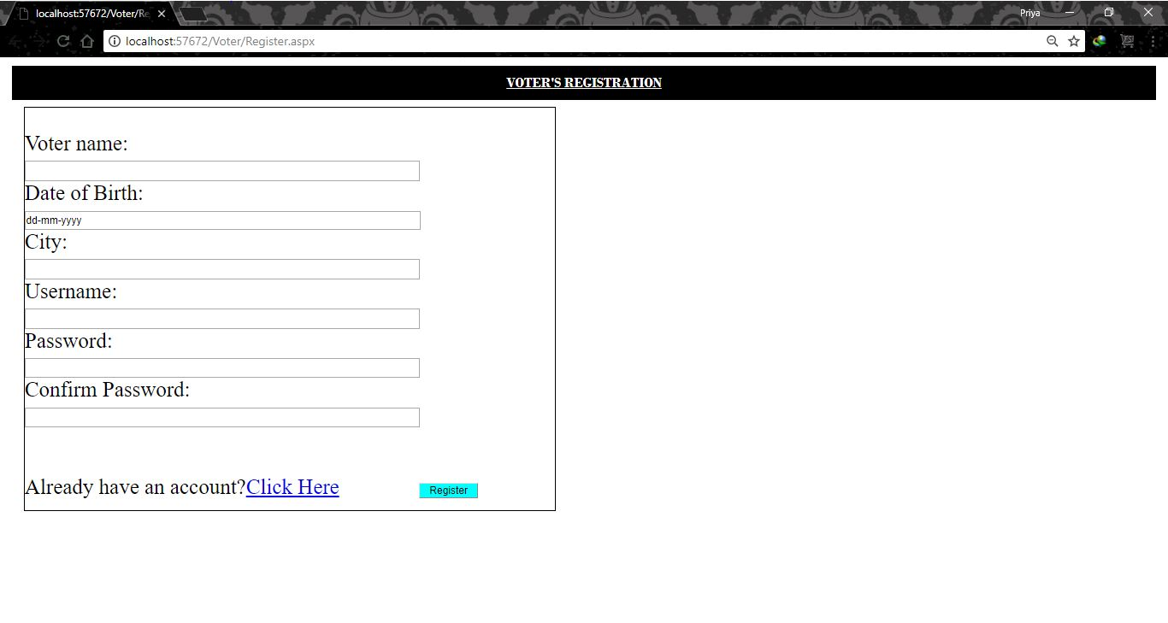

Screenshot of Database of voter:
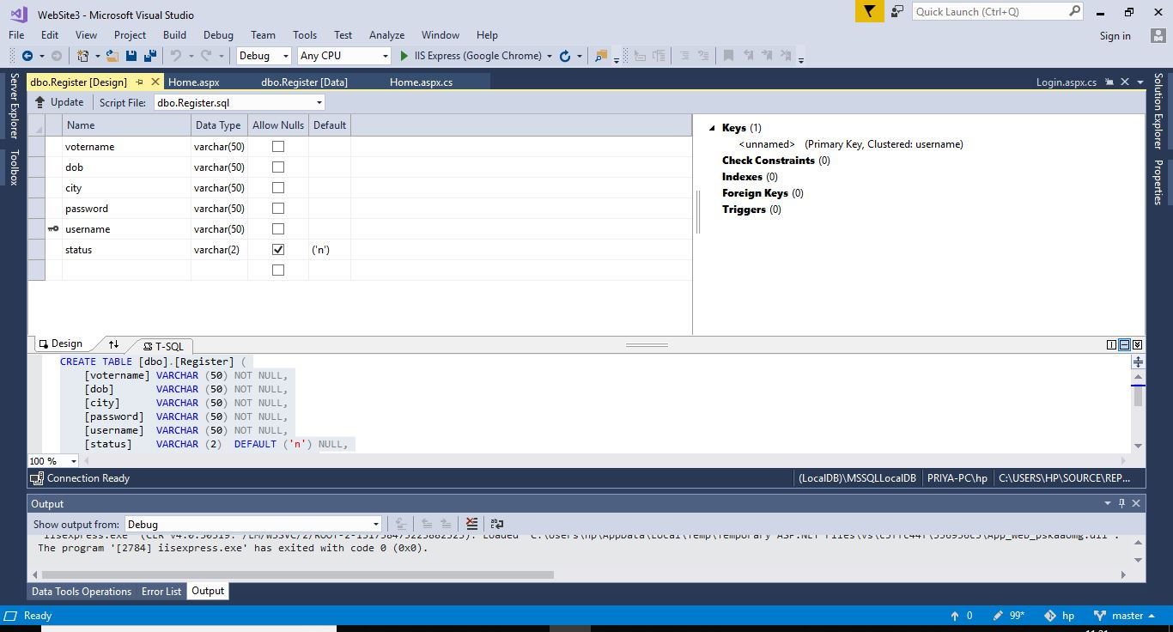

2.Home Page of Voter:
protected void Button1_Click(object sender, EventArgs e)
{
String can = DropDownList1.SelectedValue;
SqlConnection con = new SqlConnection(@"Data Source = (LocalDB)\MSSQLLocalDB; AttachDbFilename = C:\Users\hp\source\repos\WebSite3\WebSite3\App_Data\Database.mdf; Integrated Security = True");
con.Open();
SqlCommand cm1 = new SqlCommand("select status from Register where username='" + Session["u"] + "' ",con);
SqlDataReader d1 = cm1.ExecuteReader();
d1.Read();
if (d1.GetString(0).Equals("y"))
{
Label2.Text = ("You have already given vote");

}
else
{
d1.Close();
con.Close();
con.Open();
SqlCommand cm2 = new SqlCommand("Update Register set status='y' where username='" + Session["u"] + "' ", con);
SqlDataReader d2 = cm2.ExecuteReader();
con.Close();
con.Open();
SqlCommand com = new SqlCommand("update Organization set vote=vote+1 where candidate='" + can + "'", con);
SqlDataReader dr = com.ExecuteReader();
Label3.Text = "Successful in giving vote";
}
}
}

Screenshot of Voter’s Home Page:

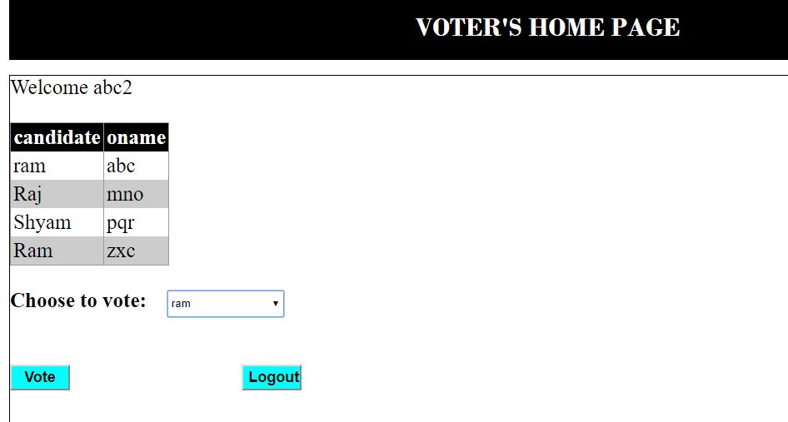

3.Candidate’s Login Page:

public partial class Candidate_Login : System.Web.UI.Page
{
protected void Page_Load(object sender, EventArgs e)
{

}

protected void Button1_Click(object sender, EventArgs e)
{
String username = TextBox1.Text;
String password = TextBox2.Text;
Session["u"] = username;
SqlConnection con = new SqlConnection(@"Data Source = (LocalDB)\MSSQLLocalDB; AttachDbFilename = C:\Users\hp\source\repos\WebSite3\WebSite3\App_Data\Database.mdf; Integrated Security = True");
con.Open();
SqlCommand com = new SqlCommand("select * from Regcan where username='" + username + "'and password='" + password + "'", con);
SqlDataReader dr = com.ExecuteReader();
bool s = dr.Read();
if (s)
Response.Redirect("Home.aspx");
else
Label1.Text = "Username or Password is incorrect";
}
}

Screenshot of Candidate’s Login Page:
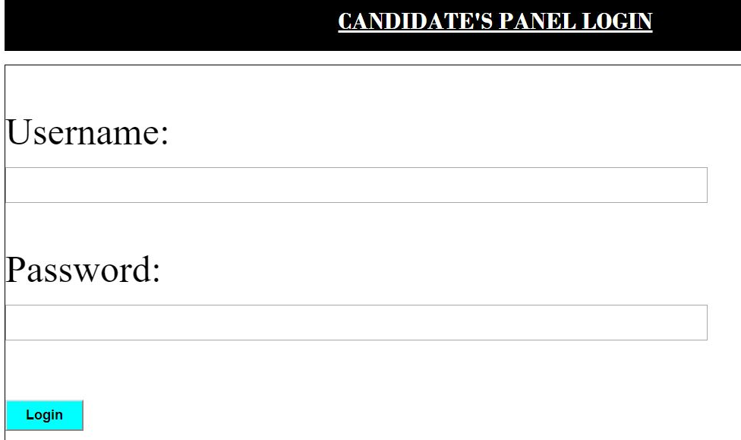

4. Organization Registration Page:

protected void Button1_Click(object sender, EventArgs e)
{
if (CompareValidator1.IsValid == true && RequiredFieldValidator1.IsValid == true && RequiredFieldValidator2.IsValid == true && RequiredFieldValidator3.IsValid == true && RequiredFieldValidator4.IsValid == true && RequiredFieldValidator5.IsValid==true && RequiredFieldValidator6.IsValid==true)

{
String oname = TextBox1.Text;
String email = TextBox2.Text;
String username = TextBox3.Text;
String password = TextBox4.Text;
String candidate = DropDownList1.SelectedValue;
SqlConnection con = new SqlConnection(@"Data Source = (LocalDB)\MSSQLLocalDB; AttachDbFilename = C:\Users\hp\source\repos\WebSite3\WebSite3\App_Data\Database.mdf; Integrated Security = True");
con.Open();
SqlCommand com = new SqlCommand("insert into Organization (oname,email,username,password,candidate) values('" + oname + "','" + email + "','" + username + "','" + password + "','"+candidate+"')", con);
SqlDataReader dr = com.ExecuteReader();
Response.Redirect("Login.aspx");
}
}

Screenshot of Organization Registration Page:

